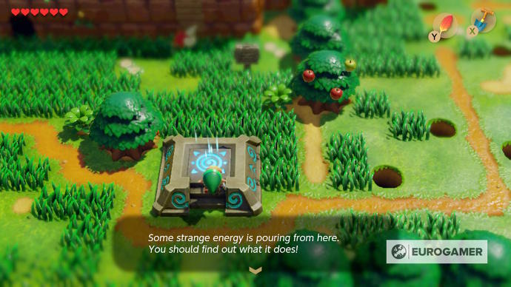Tyler Hales

1/13/2020

* Number of Players: 1
* Ages 10+
* Escape the Island!
  + Embark in a top-down perspective, action-adventure style journey. You, as the player, must traverse and fight through the monster/skeleton infested island and collect certain keys to unlock doors/gates to ultimately arrive at a portal to safely transport you off the island. Fight enemies using your sword, bow, and magic. Solve puzzles to find important items and keys and make your way to the finish.
* Enjoy a new take and combination of some of your favorite action-adventure style games. Let’s say it’s a Jumanji-Zelda kind of game.

